**CATARACT PRE- AND POST OP DROPS**

**Use your moisturizing drops Systane/Optive Fusion 1-2 weeks prior to surgery,**

**Use 1 drop 4 times a day and continue as required after your procedure.**

**SPERSADEX-COMP**

START DROPS 1 DAY BEFORE SURGERY

TAKE 1 DROP 3 TIMES DAILY AND USE FOR 1 WEEK

BRING YOUR DROP TO THE HOSPITAL ON THE DAY OF SURGERY

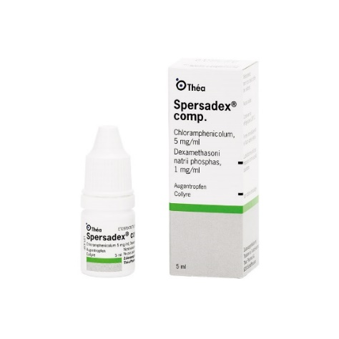

**Nevanac**

START DROPS 1 DAY BEFORE SURGERY AND CONTINUE UNTIL THE BOTTLE IS FINISHED

TAKE 1 DROP THREE TIMES A DAY

BRING YOUR DROP TO THE HOSPITAL ON THE DAY OF SURGERY

